AI Image Generator
Software Requirement Specifications (SRS)
<Version 1.0>

Project Phase I (ECS799)
Degree
BACHELOR OF TECHNOLOGY (CSE)

PROJECT GUIDE:  Mr. Ajay Chakravarthy | SUBMITTED BY:  Prince Kumar Singh (TCA2209128)  Bhishmraj (TCA2209050)

November, 2025



FACULTY OF ENGINEERING & COMPUTING SCIENCES
TEERTHANKER MAHAVEER UNIVERSITY, MORADABAD

Revision History
Author/ Changes made by | Date | Reason For Changes | Version
<Project ID> Team | 26-08-2025 | initial draft | 1.0 draft
<Project ID> Team | 27-11-2025 | baseline following changes after inspection | 1.0 approved

Approved by:
Project Guide Name: Mr. Ajay Chakravarthy

Signature:

Table of Contents

1 Introduction 4
1.1 Purpose 4
1.2 Scope of the Work 4
1.3 Definitions, Acronyms, and Abbreviations 4
1.4 References 5
2 Overall Description 6
2.1 Product Perspective 6
2.2 Product Functions 6
2.3 User Characteristics 6
2.4 General Constraints 7
2.5 Assumptions and Dependencies 7
3 Specific Requirements 7
3.1 <Name of Function 1> 8
3.1.1 Description 8
3.1.2 Inputs 8
3.1.3 Processing 8
3.1.4 Outputs 8
3.1.5 Error Handling 8
3.1.6 Test Cases for <Function 1> 8
3.2 <Name of Function 2> 8
3.2.1 Introduction 8
3.2.2 Inputs 8
3.2.3 Processing 8
3.2.4 Outputs 9
3.2.5 Error Handling 9
3.2.6 Test Cases for <Function 2> 9
3.3 Design Constraints 9

Appendix A: Data Flow Diagram (DFD)
Appendix B: Entity-Relationship Diagram (ERD)
Appendix C: Use-Case Diagram (UCD)
Appendix D: Data Dictionary (DD)
Appendix E: Screen Shots

Introduction
This Software Requirements Specification (SRS) document provides a complete and detailed description of the AI Image Generator application. It outlines the purpose, scope, and overall objectives of the system, along with the essential definitions, references, assumptions, and constraints that guide the development process. The document is intended to serve as a foundation for designers, developers, testers, and stakeholders by clearly identifying what the system must achieve.
The AI Image Generator application is designed to generate high-quality images based on user-provided text prompts using artificial intelligence techniques. As AI-driven creative tools become increasingly popular, this system aims to offer an intuitive, accessible, and powerful platform for generating realistic, conceptual, artistic, and illustrative visuals without requiring any design skills.

Purpose
The purpose of this Software Requirements Specification (SRS) document is to define and describe the functional and non-functional requirements of the AI Image Generator application. This document serves as a formal agreement between the stakeholders, including project supervisors, developers, testers, and end users, ensuring that all parties share a clear and consistent understanding of the system’s intended features and behavior.
The primary purpose of the AI Image Generator system is to enable users to generate high-quality images from text-based prompts using artificial intelligence and deep learning models. The system aims to simplify the image creation process for users who may not possess advanced design or artistic skills by allowing them to produce creative, realistic, or stylized visual outputs through natural language input.

Scope of the Work
- Allowing users to enter text prompts to generate images.
- Supporting optional image-to-image generation for style transformation or enhancement.
- Enabling users to customize output parameters such as style, resolution, aspect ratio, filters, and creativity level.
- Providing user account management, including login, history tracking, and saving generated images.
- Offering a responsive and user-friendly interface suitable for both mobile and desktop devices.
- Integrating a secure backend system to manage prompt processing, image generation requests, and image storage.
- Ensuring that the system is scalable to handle multiple simultaneous image generation requests.
The system does not cover advanced professional editing features such as multi-layer image manipulation, animation creation, or commercial-grade photo editing tools in the initial release. Future enhancements may include advanced AI models, batch processing, or premium features.
Overall, the scope of the AI Image Generator application is to provide an accessible, intuitive, and efficient platform for transforming creative ideas into AI-generated visual content.

Definitions, Acronyms, and Abbreviations

Acronym | Full Form
SRS | Software Requirements Specification
UI | User Interface
UX | User Experience
JSON | JavaScript Object Notation
DBMS | Database Management System
HTTP/HTTPS | Hypertext Transfer Protocol / Secure Hypertext Transfer Protocol
CPU | Central Processing Unit
GPU | Graphics Processing Unit
DB | Database

Term | Definition
AI (Artificial Intelligence) | The field of computer science that focuses on building systems capable of performing tasks that typically require human intelligence.
Machine Learning (ML) | A subset of AI that enables systems to learn patterns from data and improve performance over time without explicit programming.
Deep Learning | A type of machine learning that uses neural networks with many layers to model complex patterns in data.
Generative Model | An AI model designed to create new data samples, such as images, based on learned patterns.
Prompt | A text-based instruction or description provided by the user to guide image generation.
Image-to-Image Generation | A feature where the input image is transformed or enhanced based on user-defined settings or styles.
Render Time | The amount of time required by the system to produce the final generated image.
API (Application Programming Interface) | A set of functions allowing interaction between the frontend, backend, and AI model services.
Resolution | The dimensions of the generated image, usually measured in pixels (width × height).

Abbreviation | Meaning
Img | Image
Gen | Generation
Auth | Authentication
Req | Requirement
User ID | Unique identifier assigned to a user account

References
This subsection lists all documents, standards, protocols, and resources referenced throughout this Software Requirements Specification (SRS). These references provide additional background, technical guidelines, and supporting information used during the preparation of this document.
S# | Reference Details | Owner | Description | Date
 | IEEE 830–1998: IEEE Recommended Practice for Software Requirements Specification | Institute of Electrical and Electronics Engineers (IEEE) | Standard guidelines for writing SRS documents | 1998
 | REST API Design Guidelines | Representational State Transfer (REST) community | Industry-standard practices for designing RESTful APIs | Various edition
 | HTTP/1.1 Specification (RFC 2616) | Internet Engineering Task Force (IETF) | Defines HTTP protocol used for client-server communication | June 1999

Overall Description
This section provides a high-level overview of the AI Image Generator system, focusing on general factors that influence the product and its requirements. It describes the context, purpose, and operational environment in a way understandable to customers, users, and stakeholders. No specific, measurable requirements are stated here—these will be defined in Section 3.

Product Perspective
The AI Image Generator is an independent, self-contained software application designed to generate high-quality images from textual prompts using artificial intelligence. It incorporates advanced machine learning and deep learning models to interpret user instructions and produce visual outputs tailored to user preferences such as style, resolution, or artistic theme.
The system interacts with:
- A cloud-based AI model or API for image generation
- A database for user accounts, history, and saved outputs
- A web or mobile-based user interface for prompt submission
The system acts as a black box from the user’s perspective: the user enters a prompt, the system processes it using an AI model, and an image is generated and returned.

Product Functions
At a high level, the system provides the following functions:
- Accepting text prompts from users to generate images
- Allowing modification of prompts (refinement, regeneration, variations)
- Generating images based on AI models using style, resolution, and configuration options
- Providing download, share, and save options for generated images
- Allowing user authentication and profile management
- Storing user generation history
- Supporting image-to-image transformations (optional)
- Offering prompt suggestions and predefined templates
These functions are described in detail in Section 3 for developers.

User Characteristics
The intended users of the system include:
- General Users: Casual users with basic technology familiarity who want to generate images for fun, creativity, or simple tasks.
- Content Creators/Designers: Users with moderate technical experience who require higher-quality images for social media, design work, or professional tasks.
- Students and Developers: Users experimenting or learning about AI models who may use the system frequently.
Overall, users may have varying levels of technical expertise. This variability influences the design to ensure:
- Easy navigation
- Simple language
- Clear instructions
- Fast and intuitive controls
- Robust error handling

General Constraints
The development and operation of the system may be constrained by several factors:
- Performance Constraints: Image generation relies on GPU-based models, which may introduce delays depending on server load.
- Security Constraints: User accounts and stored images must follow standard encryption and authentication practices.
- API Dependencies: The system may rely on third-party AI model providers, which impose limits such as API quotas, model usage restrictions, or rate-limits.
- Hardware/Hosting Constraints: The system must run within standard cloud or shared hosting environments.
- Legal Constraints: Generated images must comply with copyright, ethical AI usage, and content safety guidelines.
- Network Constraints: The system requires stable internet connectivity since model processing occurs on remote servers.

Assumptions and Dependencies
The requirements defined in this document are based on several assumptions and external dependencies:
- Cloud-based AI model services (e.g., Stable Diffusion, OpenAI models) will remain accessible and functional.
- Users will have internet access to use the application.
- The system assumes availability of a standard web browser or mobile device environment.
- The backend server is assumed to support modern frameworks and database systems.
- API or model updates from third-party providers may affect system behavior and require updates to requirements.
- Expected user volumes will remain within planned limits unless scaling is implemented.

Specific Requirements
This section details all functional requirements of the system. Each requirement is defined with clear inputs, processing steps, outputs, error handling, and test cases. These requirements guide developers and testers in implementing and validating the system.

<User Login & Authentication>

Description
This function enables users to securely log into the application using their registered email and password. The system shall validate credentials, authenticate the user against stored data, and provide secure access to the application dashboard.

Inputs
• User Email ID
• User Password
• “Login” button click event

Processing
• The system shall verify that both email and password fields are not empty.
• The system shall validate email format (e.g., abc@xyz.com).
• The system shall encrypt the password before sending it to the server.
• The system shall fetch user credentials from the User Table and compare them with the input.
• If credentials match, user status is updated to “Active Session.”

Outputs
• Successful login message
• Access to Dashboard screen
• Error message if login fails

Error Handling
• If email format invalid → Display: “Please enter a valid email.”
• If any field empty → Display: “All fields are mandatory.”
• If credentials incorrect → Display: “Invalid email or password.”
• If server not reachable → Display: “Unable to connect. Try again later.”

Test Cases for <Function 1>
Test Case ID | Test Title | Test Case Description | Pre-condition | Expected Result
TC001 | Valid Login | User enters correct email & password | User account exists | User successfully logs in and dashboard opens
TC002 | Invalid Password | User enters correct email but wrong password | User account exists | System displays “Invalid email or password.”
TC003 | Empty Fields | User clicks login without entering details | None | System displays “All fields are mandatory.”

<Text-to-Image Generation>

Introduction
This function generates AI images based on user-submitted text prompts using integrated AI model APIs.

Inputs
• Text Prompt
• Optional fields: Style, Resolution, Model Version, Seed
• Generate button click event

Processing
- The system shall validate that the prompt is not empty.
- The system shall send the prompt + settings to the AI model API.
- The system shall store the request in GENERATION_HISTORY table.
- The system shall fetch the resulting image URL or file from the API.
- The system shall store generated image metadata in IMAGES table.

Outputs
• AI-generated image displayed to the user
• Option to download or save image
• Generation time message (“Image generated in X seconds.”)

Error Handling
• Empty prompt → “Please enter a prompt.”
• API failure → “Generation failed. Try again later.”
• Timeout → “Request timed out. Please retry.”

Test Cases for <Function 2>
Test Case ID | Test Title | Test Description | Pre-condition | Expected Result
TC004 | Valid Prompt | User enters prompt → generates image | User logged in | AI image appears
TC005 | Empty Prompt | User clicks generate with no text | None | Error: “Please enter a prompt.”
TC006 | API Failure | API returns error | API down | Error displayed to user

Design Constraints
The following design constraints define external limitations that influence the architecture, development, or deployment of the system:

3.3.1 Hardware Constraints
- The system shall run on Android smartphones with a minimum of 2 GB RAM.
- The system shall support devices running Android OS version 8.0 (Oreo) or above.
- Limited device storage may restrict the amount of offline weather data that can be stored locally.

3.3.2 Software Constraints

- The application shall be developed using python as per organizational development standards.
- The system shall use the Android SDK and comply with Google Material Design Guidelines.
- The application shall integrate with a third-party Weather API, which may impose API rate limits and request quotas.
- All communication with external services shall use HTTPS for secure data transfer.

3.3.3 Regulatory & Standards Constraints

- The system shall comply with relevant data privacy regulations, including:
  - GDPR-equivalent principles for user data protection,
  - Indian IT Act guidelines for digital data security.
- The system must follow Open Weather API usage policies (or whichever API you are using).

3.3.4 Organizational Constraints

- The development must follow the organization’s coding standards, version control policies, and documentation formats.
- The system shall be compatible with the company's existing backend service endpoints (if any).

    - Operational Constraints

- The app requires an active internet connection to fetch real-time weather data.
- GPS-based location retrieval requires access to device location services, which the user must grant.

Appendix A
Data Flow Diagram (DFD)
(Mandatory)

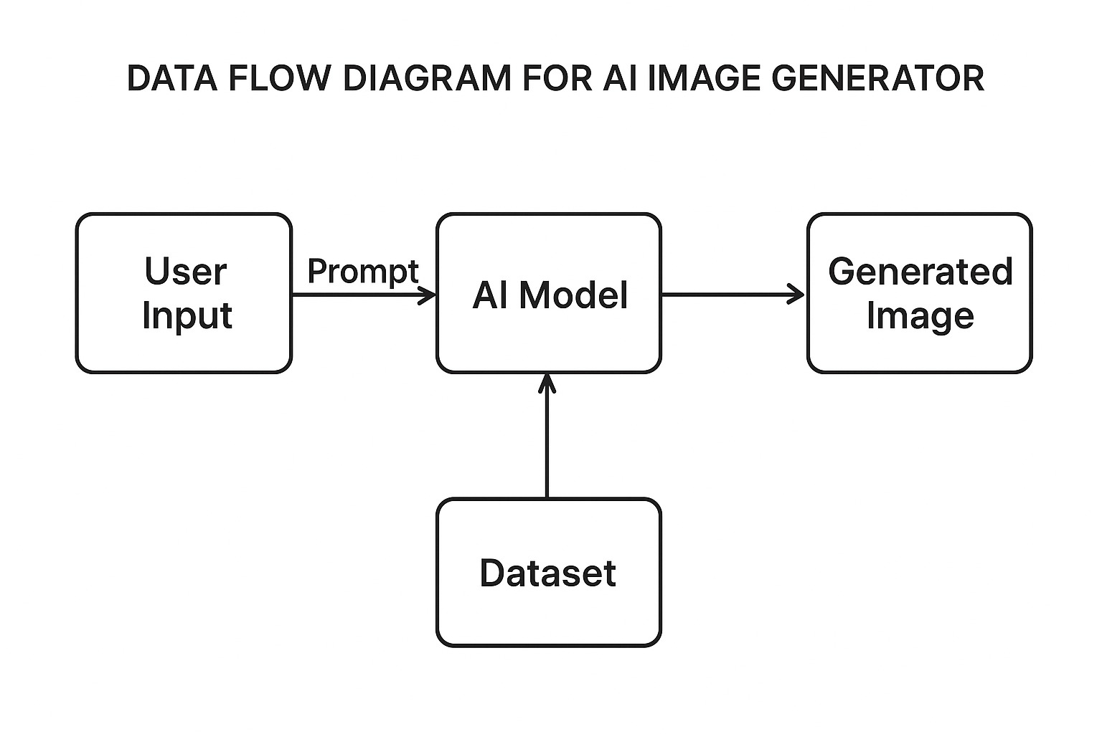

Appendix B
Entity-Relationship Diagram (ERD)
(Mandatory)

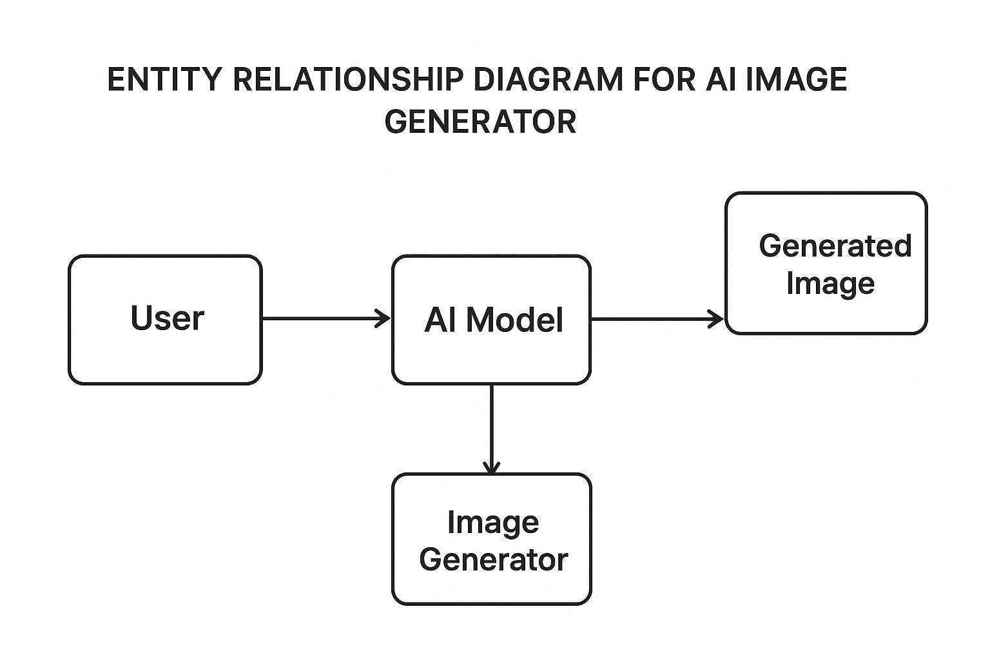
Appendix C
Use-Case Diagram (UCD)
(Optional)

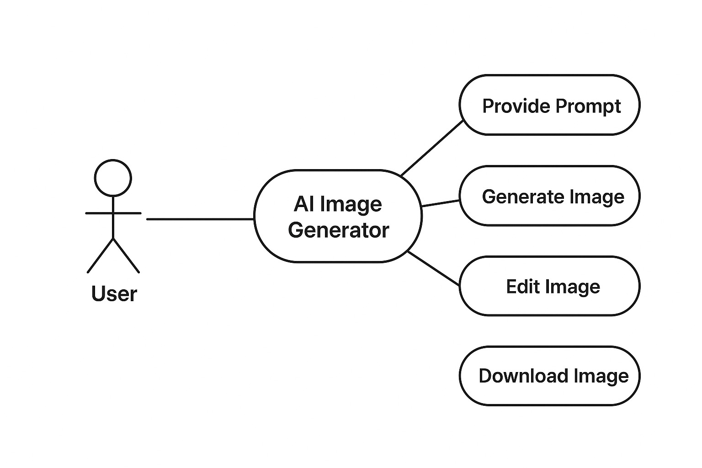
Appendix D
Data Dictionary (DD)
(Mandatory)

Example:
User Table (USR)
Fields | Data Type | Description
USR-ID | Number | Unique User ID (Primary Key)
USR-Name | Text | Registered user’s full name
USR-Email | Text | User email address (unique)
USR-Password | Text | Hashed user password
USR-Role | Text | User role (Admin/User)
USR-Created-On | DateTime | Account creation timestamp

Prompt Table (PRM)
Fields | Data Type | Description
PRM-ID | Number | Unique Prompt ID (Primary Key)
PRM-User-ID | Number | ID of User who created the prompt (Foreign Key)
PRM-Text | Text | User input text used for image generation
PRM-Style | Text | Selected image style (realistic, anime, 3D, etc.)
PRM-Resolution | Text | Resolution chosen for output image
PRM-Created-On | DateTime | Timestamp when prompt was submitted
Image Table (PRM)
Fields | Data Type | Description
IMG-ID | Number | Unique Image ID (Primary Key)
IMG-PRM-ID | Number | Linked Prompt ID (Foreign Key)
IMG-URL | Text | Cloud/local storage URL of generated image
IMG-Format | Text | Image format (e.g., PNG, JPG)
IMG-Size | Number | Image file size (KB/MB)
IMG-Created-On | DateTime | Timestamp when image was generated

Feedback Table (PRM)
Fields | Data Type | Description
FDB-ID | Number | Unique Feedback ID (Primary Key)
FDB-User-ID | Number | ID of User giving feedback (Foreign Key)
FDB-IMG-ID | Number | ID of Image being reviewed (Foreign Key)
FDB-Rating | Number | Rating given by user (1–5)
FDB-Comment | Text | User comment or feedback
FDB-Created-On | DateTime | Timestamp of feedback submission

Appendix E
Screen Shots
<Guidelines: Show all Pages>
Home Page:
